Overview of Instructional Task: Building a Fence

In this instructional task, students find the maximum area of a rectangle with a given perimeter. It is important to discuss students’ solutions and allow time to share how they record mathematical thinking so students become more confident with problem-solving strategies.
Task Window
Within Unit 3: October 1–27, 2011
Task should be implemented after students have begun work on perimeter and area but before complete mastery.
Summary of Instructional Task
- One to two days before lesson, do the section titled Before Lesson.
- The lesson plan gives suggested time allotments, questions, and prompts to support students with the task. Collaborative groups as well as whole group work is noted.
- After the lesson, students read and revise their original responses and write what they learned.
- Analyze student responses to identify next instructional steps.
Task details are included on the following pages.
- Goals, Standards, Background for Teachers (page 2)
- Lesson (pages 3–5)
- Student work samples (pages 6–9)
- Master for the task (page 10)

Instructional Task: Building a Fence
Mathematical Goals
This instructional task helps students:
- Compare and order whole numbers (Number and Numeration Goal 6).
- Count unit squares to find perimeters and areas of rectangles (Measurement and Reference Frames Goal 2).
Common Core State Standards
This instructional task emphasizes the following Standards for Mathematical Practice:
- Make sense of problems and persevere in solving them.
- Reason abstractly and quantitatively.
- Construct viable arguments and critique the reasoning of others.
- Model with mathematics.
- Attend to precision.
This instructional task also asks students to select and apply mathematical content from the Common Core State Standards.
3.G.7a: Multiply side lengths to find areas of rectangles with whole-number side lengths in the context of solving real-world and mathematical problems and represent whole-number products as rectangular areas in mathematical reasoning.
3.G.8: Solve real-world and mathematical problems involving perimeters of polygons, including finding perimeters given side lengths, finding unknown side lengths, and exhibiting rectangles with same perimeter and different areas or with same area and different perimeters.
Background for Teachers
This task helps students develop strategies for problem solving. In this task, students find the maximum area of
a rectangle with a given perimeter.
- Before the lesson, students attempt the task individually. Review their work and formulate questions for students to answer to improve their solutions.
- At the start of the lesson, students work alone answering teacher questions about the same task.
- Then students are grouped and engage in collaborative discussions of the same task.
- In the same small groups, students are given student work samples to comment on and evaluate.
- In a whole class discussion, students explain and compare alternative solution strategies they have seen and used.
- Finally, students revise their original solutions and comment on what they learned.
Required Materials
- Copies of task, Building a Fence, for students (page 10)
- A sheet of grid paper for each student
Time
- Before lesson: 10–15 minutes
- Lesson: 60 minutes
- Total time: 70–75 minutes
Before Lesson
Initial Exploration Before Providing Student Feedback (10–15 minutes)
Before the lesson, have students read the Building a Fence task (page 10) individually and think about and record what information they know and what questions they have to answer in order to solve the task. Provide each student with a sheet of grid paper to use.
Have students work on the task individually for ten minutes. Collect students’ responses to the task. Make notes on what their work reveals about their current levels of understanding and their different problem-solving approaches.
Do not score students’ work. Research shows that it is counterproductive, as it encourages students to compare their scores and distracts their attention from what they can do to improve their mathematics.
Instead, help students make further progress by summarizing their difficulties as a series of questions, such as the suggestions below. Write a list of your own open-ended questions, based on your students’ work. You may write questions on each student’s work or select a few questions that will help the majority of students to write on the board at the beginning of the lesson. You may also note students with particular issues, so you can ask them about their difficulties in the formative lesson.
Common Issues | Suggested Questions and Prompts
Student has difficulty getting started. | - What do you know?  - What do you need to find out?
Student has difficulty with vocabulary. | - What mathematical words could you use in your solution?  - Review the words perimeter and area.
Student works unsystematically. | - Can you organize your work in a different way?  - Would labeling your work help?  - How will you know you have found all possible rectangles?
Student presents work poorly. | - Would someone unfamiliar with your type of solution easily understand your work?  - Have you explained how you arrived at your answer?
Student produces correct solution.  Student needs extension task. | - Can you now use a different method? For example…  - Is this method better than your original one? Why?  - Could you describe any patterns you see?
Suggested Lesson Outline
Improve Individual Solutions to Instructional Task (10 minutes)
Recall what we looked at yesterday. What was the task? I have read the work you have done, and I have some questions about your work. I would like you to work on your own to answer my questions for about ten minutes.
Small Group Collaborative Work (10 minutes)
Organize the class into small groups of two or three students and distribute a blank Building a Fence task (page 10) to each group. Ask students to try the task again; this time combining their ideas.
Put your own work aside until later in the lesson. I want you to work in groups now. Your task is to produce
a solution that is complete and expands on your individual solutions.
While students work in small groups, note different student approaches to the task and support student problem solving.
Note Different Student Approaches to Task
Use this information to focus a whole class discussion towards the end of the lesson. In particular, note any common mistakes.
Support Student Problem Solving
Try not to make suggestions that move students towards a particular approach to this task. Instead, ask questions that help students clarify their thinking. To help students really struggling with the task, use the questions on the previous page to support your questioning.
If the whole class struggles with the same issue, write relevant questions on the board. You could also ask students who performed well on the task to help struggling students. If students are having difficulty making any progress at all, hand out the student work samples (pages 6–9) to model problem-solving methods.
Collaborative Analysis of Student Work Samples (20 minutes)
After students have had sufficient time to attempt the task, give each small group of students copies of the student work samples (pages 6–9) and ask for written comments. This step gives students the opportunity to evaluate a variety of possible approaches to the task, without providing a complete solution strategy.
Imagine you are the teacher and have to assess this work. Correct the work and write comments on the accuracy and organization of each response.
Each student work sample poses specific questions for students to answer. In addition to these questions, you could ask students to evaluate and compare responses. To help them do more than check if the answer is correct, you may ask the following questions.
- How did this student organize his or her work?
- What mistakes have been made?
- What isn’t clear?
- What questions would you like to ask this student?
- In what ways might the work be improved?
Every group may not have enough time to work through all student work sample questions. If so, be selective about what you hand out. For example, groups that successfully completed the task using one method might benefit from looking at different approaches. Other groups that struggled with a particular approach may benefit from seeing a student version of the same strategy.
During small group work, support students as before. Note similarities and differences between students’ approaches during small group work and student work sample approaches. Also check which methods students have difficulties understanding to focus the next activity, a whole class discussion.
Whole Class Discussion: Compare Different Approaches (10 minutes)
Organize a whole class discussion to consider different approaches used in the student work samples. Focus the discussion on those parts of the small group tasks that students found difficult. Ask students to compare different solution methods.
- Which approach did you find easiest to understand? Why?
- Which approach did you find most difficult to understand? Why?
Review Original Solutions to Task (10 minutes)
Ask students to read their original responses to the task.
Read your original solutions and think about your work on this task. Write down what you learned.
Which method would you prefer to use if you were doing the task again? Why?
Encourage students to compare new approaches they learned during the task with their original methods.
Solutions
To find the largest area, all possible rectangles with a perimeter of 24 units are drawn and dimensions are labeled (i.e., 1 x 11, 2 x 10, 3 x 9, 4 x 8, 5 x 7, 6 x 6).
The rectangle with 36 square units has the maximum area. Student may bring up that the 6 x 6 rectangle is a square, which provides an opportunity to discuss attributes of squares and rectangles. We want students to understand that squares are rectangles (a special type of rectangle) because of their attributes. Note: All squares are rectangles, but only some rectangles (all sides are equal in length) are squares.
The explanation describes the steps for finding the largest area and describes counting the squares or multiplying to find the area.

Sample 1: Student A
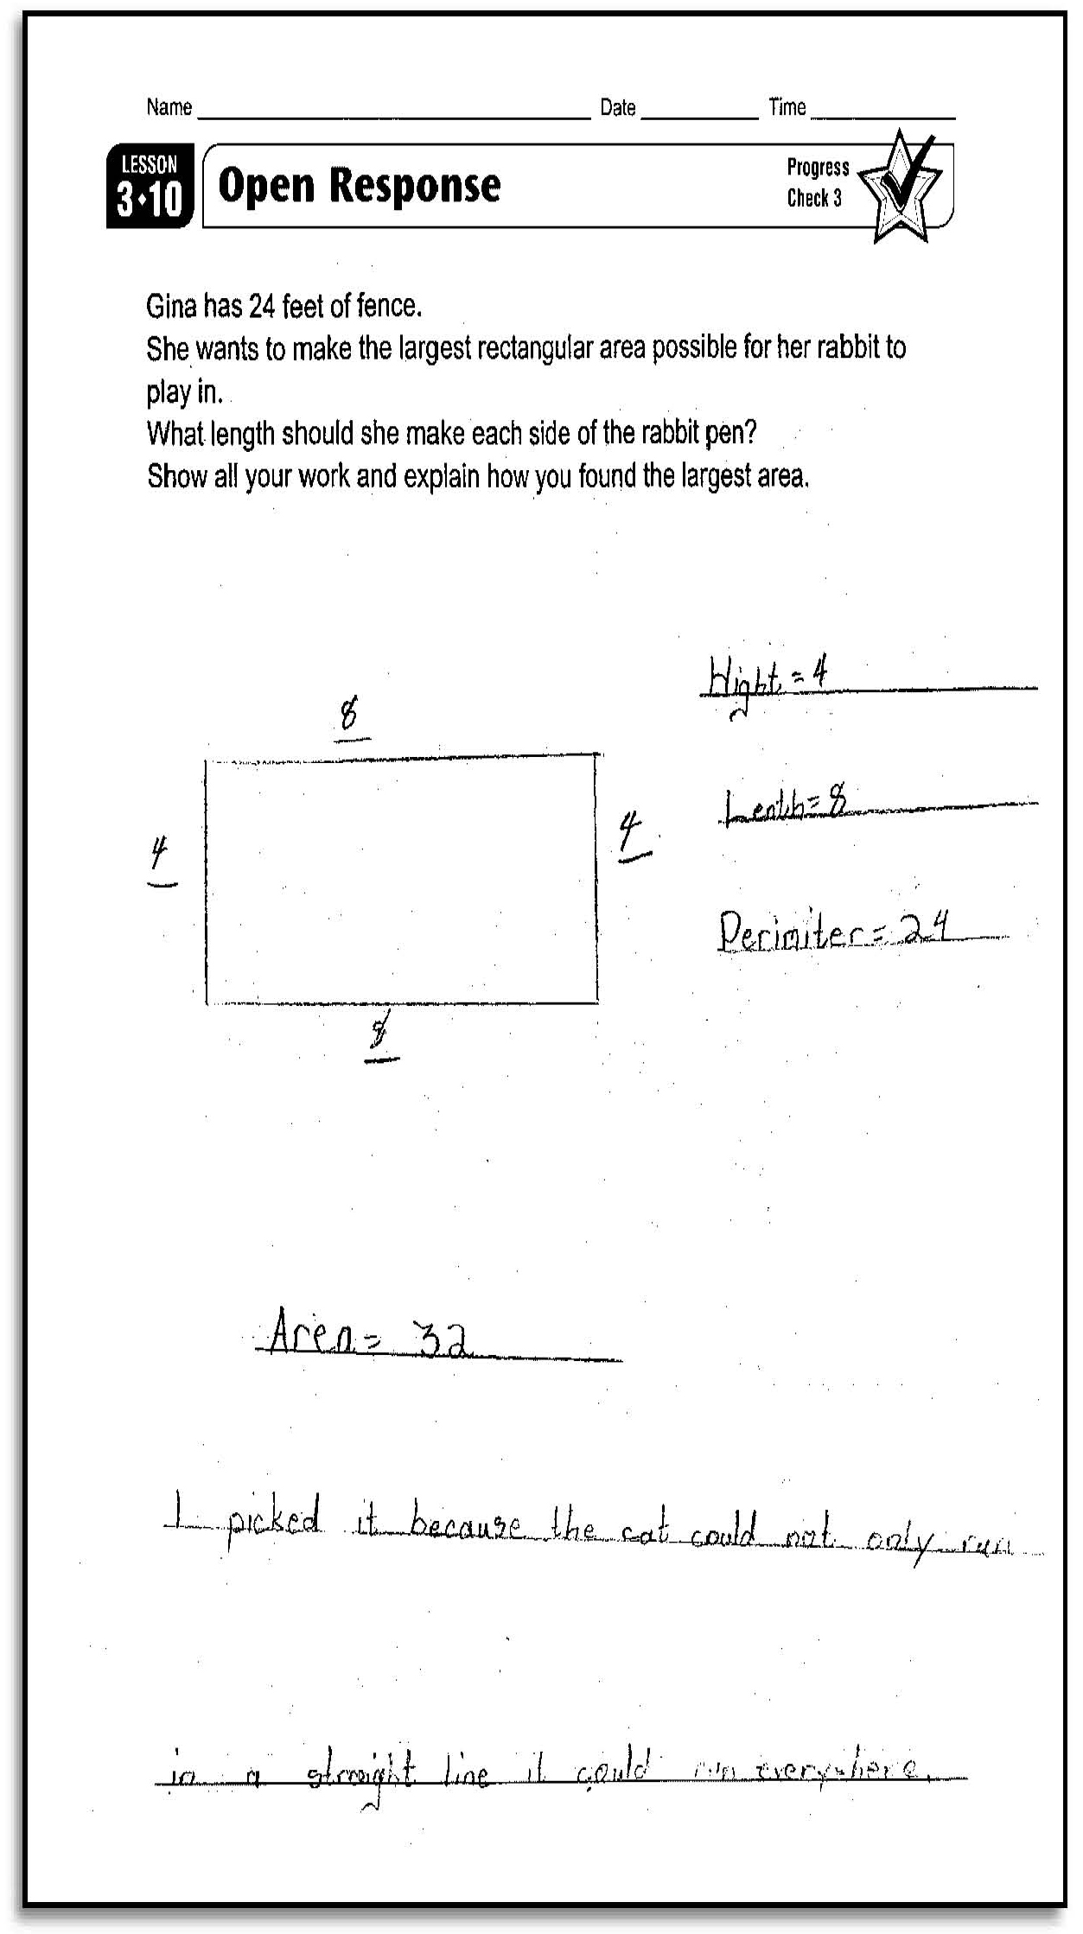
What strategy did this student use to find the perimeter of the rectangle?

What would you ask this student to do to improve this solution?

Sample 2: Student B
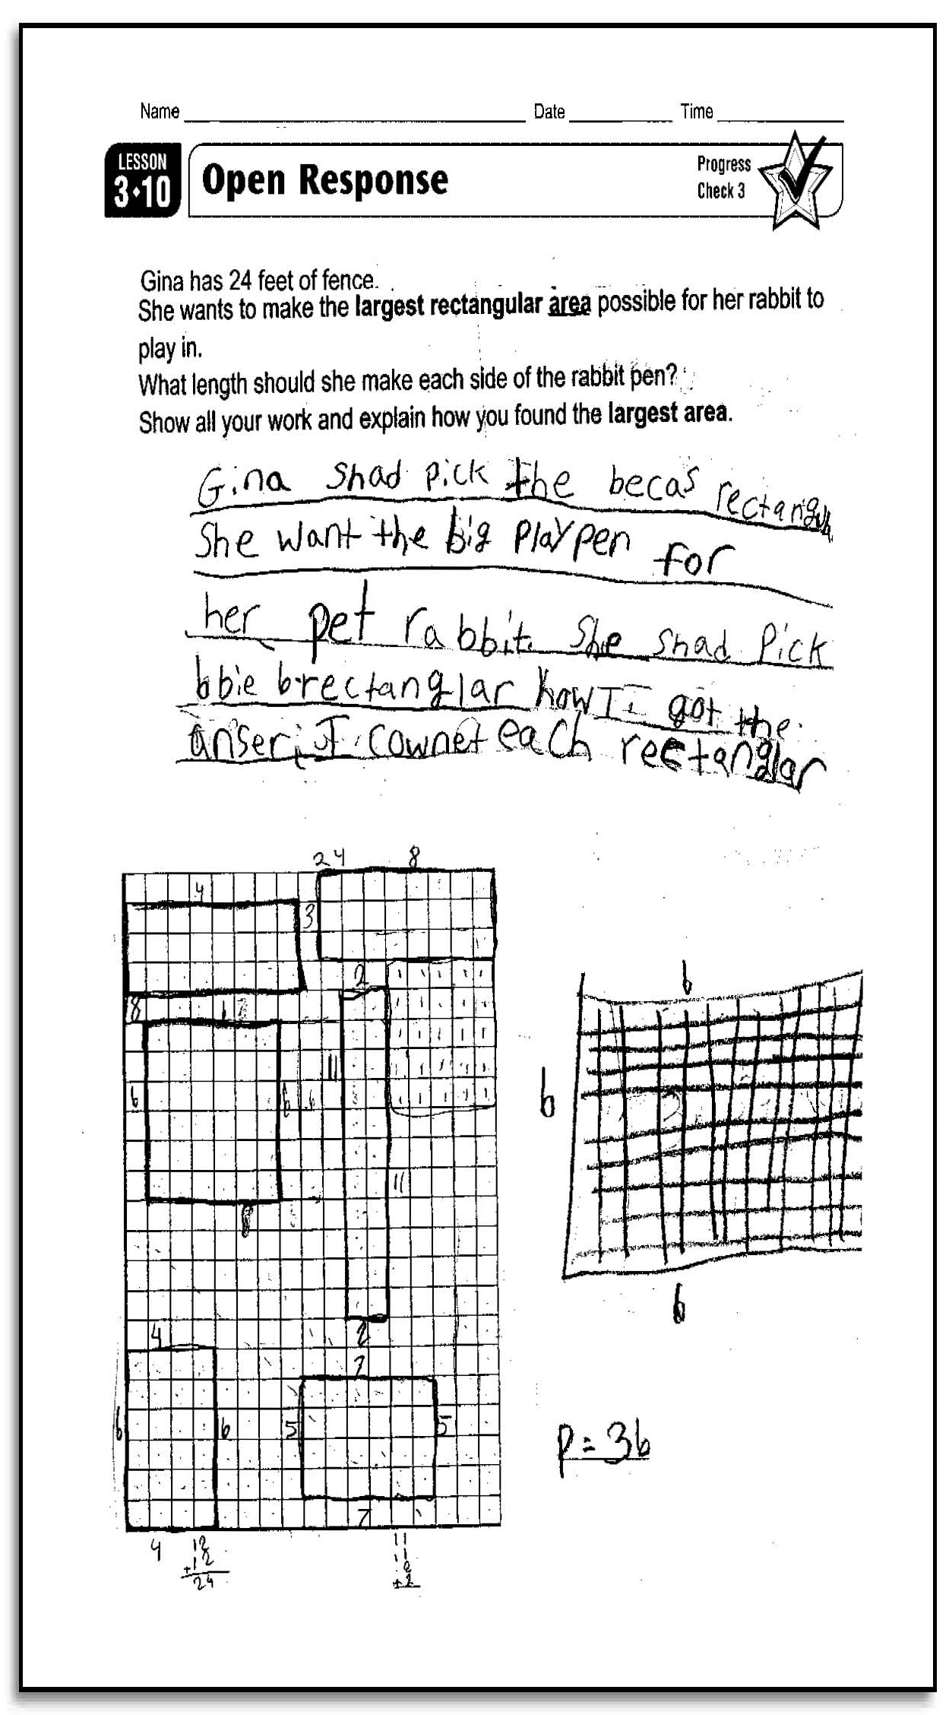
Looking at the drawings of the rectangles, what would you ask this student to improve his or her solution?

Did the student explain how he or she found the largest rectangle, and if so, is the explanation clear?
If not, how could he or she make it clear?



